UNY 2018

ISBN xxxx yyyy

The Title should Convey to the Objective/Purpose of the Paper: The Nicer the Better (Center, Bold, 16 pts)

**First Author1, Second Author2, and Last Author3* (11 pts)**

1First Author Affiliation, First Author Affiliation (10 pts)

2Second Author Affiliation, Second Author Affiliation (10 pts)

3Last Author Affiliation, Last Author Affiliation (10 pts)

firstauthor@email.com, secondauthor@email.com, and lastauthor@email.com (9 pts)

*Corresponding Author

Received: day month 201x, Revised: day month 201x, Accepted: day month 201x

Published online: day month 201x

**Abstract:** The abstract is a very brief overview of your ENTIRE study. It tells the reader WHAT you did, WHY you did it, HOW you did it, WHAT you found, and WHAT it means. The abstract should briefly state the purpose of the research (introduction), how the problem was studied (methods), the principal findings (results), and what the findings mean (discussion and conclusion). It is important to be descriptive but concise--say only what is essential, using no more words than necessary to convey meaning. The Abstract should be 100 to 200 words in length. (10 pts)

**Keywords:** Keyword 1; Keyword 2; Keyword 3; Keyword 4; Keyword 5. (10 pts separately by a semicolon)

1. **Introduction (13 Points, bold)**

The introduction comes at the start of a piece of writing. It introduces the research by situating it (by giving background), presenting the research problem and saying how and why this problem will be "solved." Without this important information the reader cannot easily understand the more detailed information about the research that comes later in the paper. It also explains why the research is being done (rationale) which is crucial for the reader to understand the significance of the study. (11 pts)

* 1. **The Structure (11 Points, bold)**

1. What is the context of this problem? In what situation or environment can this problem be observed? (Background)
2. Why is this research important? Who will benefit? Why do we need to know this? Why does this situation, method, model or piece of equipment need to be improved? (Rationale/justification)
3. What is it we don’t know? What is the gap in our knowledge this research will fill? What needs to be improved? (Problem Statement)
4. What steps will the researcher take to try and fill this gap or improve the situation? (Objectives)
5. Is there any aspect of the problem the researcher will not discuss? Is the study limited to a specific geographical area or to only certain aspects of the situation? (Scope)
   * 1. **Reference citations (11 Points, bold)**

Reference citations in the text should be identified by numbers in square brackets [1], [2,3], [4-7] and etc.

Outline of the rest of the paper: "The remainder of the paper is organized as follows. In Section 2, we introduce ... Section 3 describes ... Finally, we describe future work in Section 5." [Note that Section is capitalized. Also, vary your expression between "section" being the subject of the sentence, as in "Section 2 discusses ..." and "In Section, we discuss ...".]

1. **Related Works/Literature Review (13 Points, bold)**

“The literature" means the works you consulted in order to understand and investigate your research problem. In other words, the literature review is a *critical look* at the existing research that is significant to the work that you are carrying out. It is not supposed to be just a summary of other people's work!

You *evaluate* relevant research work, show the *relationships* between different work, and show how it relates to *your* work ( what work has already been done in your research area). Show how it relates to the other work (e.g. What other methodologies have been used? How are they similar? How are they different?) and show how it relates to *your* work (what is its relationship to your methodology?).

You cannot simply give a concise description of, for example, an article: you need to select what parts of the research to discuss (e.g. the methodology), show how it relates to the other work (e.g. What other methodologies have been used? How are they similar? How are they different?) and show how it relates to *your* work (what is its relationship to your methodology?). (11 points)

1. **Material & Methodology**
   1. **Data**

Explanation of how data was collected/generated, explanation of how data was analyzed explanation of methodological problems and their solutions or effects. We need to know how the data was obtained because the method affects the results. Knowing how the data was collected helps the reader evaluate the validity and reliability of your results, and the conclusions you draw from them.

* 1. **Method**

The research methods must be appropriate to the objectives of the study. The methodology should also discuss the problems that were anticipated and explain the steps taken to prevent them from occurring, and the problems that did occur and the ways their impact was minimized.

* 1. **Table and Figure**

Tables and Figures are presented center, as shown below and cited in the manuscript. Figure and Table captions should be 10-point Times New Roman. Callouts should be 10-point Times New Roman, non-boldface.

* 1. **Equations and Mathematical Expressions**

Equation numbers should appear in parentheses and be numbered consecutively. All equation numbers must appear on the right-hand side of the equation and should be referred to within the text.

Throughout this section the set , for  refers to the set of literals called set of items and the set , for  refers to the data set of transactions, where each transaction  is a list of distinct items ,  and each transaction can be identified by a distinct identifier TID as described in Table 1.

**Definition 1 (See [1]).** *The confidence for an association rule , denoted  is defined as a ratio of the numbers of transactions in D contain  to the number of transactions in D contain X. Thus*

**. (1)

**Lemma 1.** (*Instant Support of Single Items Property*).*For any item ai, the items support is instantly obtained from the 1-level of DOSTrieIT. All these items or nodes have no extension or also known as SIWE.*

Proof. Based on Eq. (1), the proof is complete.

**Table 1.** A Boolean tabular representation of transactiona and item

|  |  |  |  |  |  |
| --- | --- | --- | --- | --- | --- |
| TID |  |  |  |  |  |
|  | 1 | 0 | 1 | 1 | 1 |
|  | 0 | 1 | 1 | 1 | 0 |
|  | 0 | 0 | 1 | 0 | 1 |
|  | 1 | 0 | 1 | 1 | 0 |
|  | 1 | 0 | 1 | 0 | 0 |
|  | 0 | 1 | 1 | 1 | 1 |

The results of running Lemma 1 are given in Figure 1 as follow.

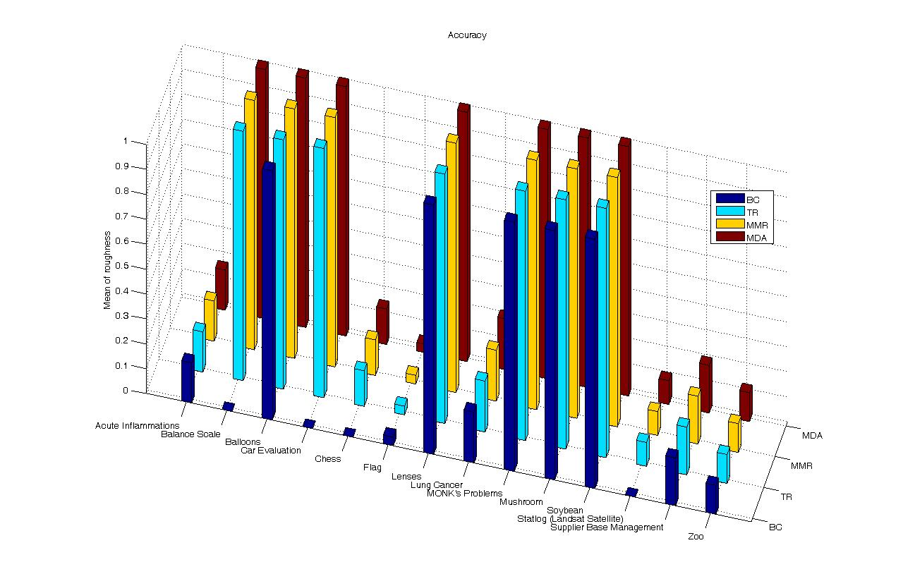

**Figure 1.** Computational results of techniques in data mining

1. **Results and Discussion**
   1. **Result**

In this sub section, the results of this work are presented.

* 1. **Statement of results**

The results are presented in a format that is accessible to the reader (e.g. in a graph, table, diagram or written text).  Notice that raw data is usually put in an appendix, if it is included at all.

* 1. **Explanatory text**

All graphs, tables, diagrams and figures should be accompanied by text that guides the reader's attention to significant results.  The text makes the results meaningful by pointing out the most important results, simplifying the results, highlighting significant trends or relationships, and perhaps commenting on whether certain results were expected or unexpected.

* 1. **Discussion**

Explanation of results: the writer comments on whether or not the results were expected, and presents explanations for the results, particularly for those that are unexpected or unsatisfactory.

References to previous research: *comparison* of the results with those reported in the literature, or use of the literature to *support* a claim, hypothesis or deduction.

Deduction: A claim for how the results can be applied more generally i.e. a conclusion based on reasoning from the results.

Hypothesis: A more general claim or possible conclusion arising from the results which will be proved or disproved in later research.

1. **Conclusion**

A conclusion should give a summary of:

1. What was learned (this usually comes first)
2. What remains to be learned (directions for future research)
3. The shortcomings of what was done (evaluation)
4. The benefits, advantages, applications, etc. of the research (evaluation), and
5. Recommendations/Future researches.

**Acknowledgement.** This research is fully supported by Affiliation Research Grant.

**References**

The list of references should only include works that are cited in the text and that have been published or accepted for publication. Personal communications and unpublished works should only be mentioned in the text. Do not use footnotes or endnotes as a substitute for a reference list.

**Journal Papers**

[1] Leung, C. K-S, Khan Q.I., Li, Z., and Hoque, T., “CanTree: A Canonical-Order Tree for Incremental Frequent-Pattern Mining,” *Knowledge and Information Systems* 11 (3), 287–311 (2007).

**Conference Proceedings Papers**

[2] Pei, J., Han, J., Lu, H., Nishio, S., Tang, S., and Yang, D, “Hmine: Hyper-Structure Mining of Frequent Patterns in Large Databases,” *In the Proceedings of IEEE International Conference on Data Mining*, IEEE Press, 441–448 (2001).

**Book**

[3] Han, J., Kamber, M., and Pei, J., “*Data Mining: Concepts and Techniques, 3rdedition*,” Morgan Kaufmann, 2011.

**Book Chapters**

[4] Tanbeer, S.K., Chowdhury, F.A., Jeong, B.S., Lee, Y-K., ”CP-Tree: A Tree Structure for Single-Pass Frequent Pattern Mining,” In T. Washio *et al*. (Eds.), *Lecture Notes in Artificial Intelligence* 5012, Springer, 1022–1027. (2008).

**Online**

[5] FIMI Dataset Repository, <http://fimi.cs.helsinki.fi/data/> Retrieved 09 August, 2011.

**Thesis**

[6] Williams, J., “*Narrow-band analyzer*,” Ph.D. dissertation, Department of Electrical Engineering, Harvard University, Cambridge, MA, 1993.

**Patent**

[7] J. P. Wilkinson, “*Nonlinear resonant circuit devices*,” U.S. Patent 3 624 12, July 16, 1990.

**Appendix**

Appendixes, if needed, appear after Reference.